951 E Bogard Rd Ste 203
Wasilla, AK 99654
Ph: 907-376-2456
Fx: 907-376-2458
Email: frontdesk@matsudental.com

Patient Name: __________________________
DOB: ______________
Date : ______________
Reason for referral:

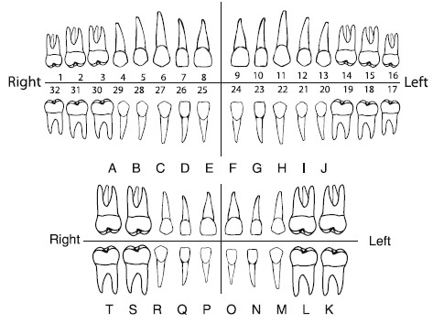
Radiographs emailed: yes ____ no ____
951 E Bogard Rd Ste 203
Wasilla, AK 99654
Ph: 907-376-2456
Fx: 907-376-2458
Email: frontdesk@matsudental.com

Patient Name: __________________________
DOB: ______________
Date : ______________
Reason for referral:

Radiographs emailed: yes ____ no ____

